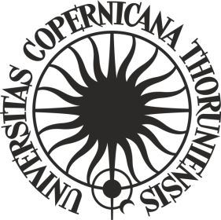**RESOLUTION Nr 29**

**By the Senate of Nicolaus Copernicus University in Toruń**

of 23 April 2024

**amending resolution No. 38 by the NCU Senate of 26 September 2023 on the procedure of awarding the doctoral title at Nicolaus Copernicus University in Toruń**

Pursuant to art. 192 section 2 and 3 of the law of 20 July 2018 Law on Higher Education and Science (Journal of Laws of 2023, item. 742 as amended) and § 124 of the resolution No. 37 by the NCU Senate of 16 April 2019, Statute of Nicolaus Copernicus University in Toruń (NCU Legal Bulletin of 2024, item 10),

**it is provided**, as follows:

§ 1

In the resolution No. 38 of the NCU Senate of 26 September 2023 on the procedure of awarding the doctoral title and Nicolaus Copernicus University in Toruń (NCU Legal Bulletin of 2023, item 329) the following changes are made:

1. in § 20, section 1 is replaced by:

„**1. Before initiating the procedure for awarding a doctoral degree, the candidate submits a doctoral thesis in accordance with the rules set out in the order referred to in § 1 section 2, item 1.**” ;

1. in § 20, after section 5, the following section 6 is added:

„**6. The provisions of sections 1-5 do not apply to candidates who have submitted their doctoral thesis as part of their education at a doctoral school of the University**”;

1. in § 21 section 3, item 1 is hereby revoked.

§ 2

The Resolution comes into force on 1 October 2024.

**Head of NCU Senate**

**prof. dr hab. Andrzej Sokala**

**R e c t o r**